Multiple-choice section

|  |  |  |  |  |  |  |  |  |  |  |  |  |
| --- | --- | --- | --- | --- | --- | --- | --- | --- | --- | --- | --- | --- |
| Question | 1 | 2 | 3 | 4 | 5 | 6 | 7 | 8 | 9 | 10 | 11 | 12 |
| Answer | D | A | A | D | B | A | C | B | A | C | D | C |

Question 1 [6.1]

D

Find the point on the graph that is to the left of the oven tray and higher than the mixing bowl:

measuring jug.

Question 2 [6.1]

A

Steepest positive line for the fastest travel speed is in section *B*.

Question 3 [6.2]

A

All points on the line *y = -*5 have a *y*-coordinate of -5. (0, -5)

Question 4 [6.2]

D

Each column in the table represents one coordinate.

Question 5 [6.2]

B

All points on the line *x = -*3 have an *x*-coordinate of -3. (-3, 2)

Question 6 [6.3]

A

*y* = 4*x* – 1

Substituting the x-coordinate of each point into the equation gives the corresponding y-coordinate.

Question 7 [6.2]

C

.Where *x* = 3, *y* = 2 × 3 + 3 = 9, so the point (3, 9) is on the line.

Question 8 [6.2]

B

Thelinewithequation crosses the *x*-axis at 2

Question 9 [6.2]

A

A line with a constant *x*-coordinate is a vertical line. Vertical lines have an undefined gradient.

Question 10 [6.2]

C

*x* +3*y* = 1

Substituting *x* = -2 into the equation gives a *y*-coordinate of 1.

*x* +3*y* = 1

-2 + 3*y* = 1

3*y* = 3

*y* = 1

Question 11 [6.2]

D

The line with equation  has a gradient of  which means that the line is not very steep.

Question 12 [6.4]

C

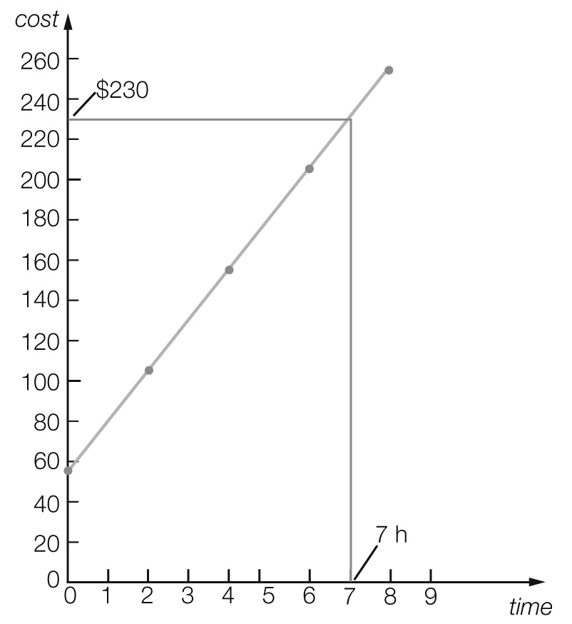

Actual value = $230

Multiple-choice total marks: 12

Short answer section

Question 13 5 marks [6.2]

(a) The *gradient* of a line is a measure of its steepness.

(b) Lines with a *positive* gradient *slope* up to the right and lines with a *negative* gradient *slope* up to the *left*.

(c) The point (0, 0) is the *origin* of the *Cartesian* plane.

(d) The *x*-intercept is where a line crosses the *x-axis* and the *y-intercept* is where a line crosses the *y*-axis.

(e) When points on a graph make a *straight line* then the relationship between the variables is *linear*.

Question 14 2 marks [6.2]

Horizontal line is *y* = -2

Vertical line is *x* = -3

Question 15 3 marks [6.1]

(a) number of legs and weight (the axis labels)

(b) spider (higher than emu and to the left of dog)

(c) emu (furthest point along top the right of the *x*-axis

Question 16 2 marks [6.1]

(a) *B*. Steeper lines show faster speeds.

(b) *C*. Horizontal lines show no movement.

Question 17 3 marks [6.2]

|  |  |  |  |  |  |  |  |
| --- | --- | --- | --- | --- | --- | --- | --- |
| *x* | -3 | -2 | -1 | 0 | 1 | 2 | 3 |
| *y* | -11 | -8 | -5 | -2 | 1 | 4 | 7 |

Question 18 4 marks [6.3]

|  |  |  |  |  |  |  |  |
| --- | --- | --- | --- | --- | --- | --- | --- |
| *x* | -3 | -2 | -1 | 0 | 1 | 2 | 3 |
| *y* | 0 | 1 | 2 | 3 | 4 | 5 | 6 |

So *y* = *x* + 3

Question 19 6 marks [6.3]

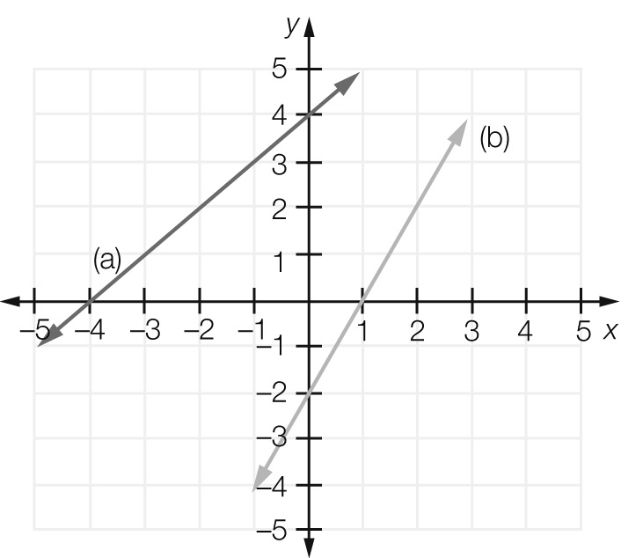

(a) *y*-intercept = 4, 

(b) *y*-intercept = -2, 

Question 20 4 marks [6.3]

(a)  (b) 

Question 21 2 marks [6.3]

*x*-intercept = (, 0); *y*-intercept = (0, )

Question 22 3 marks [6.2]

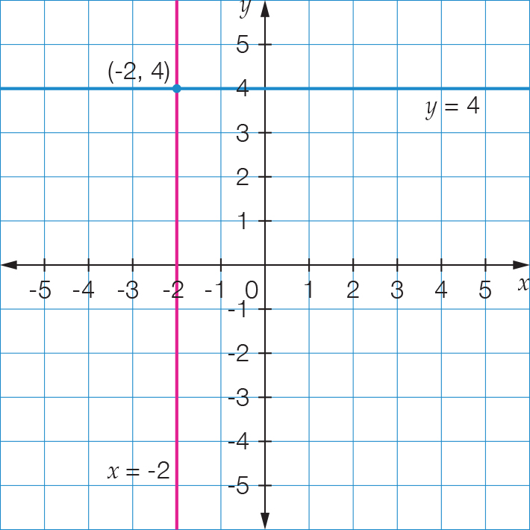

Point of intersection: (-2, 4)

Question 23 1 mark [6.3]

Line has gradient of zero and passes through (-4, 3). Rule: 

Question 24 1 mark [6.3]

Vertical line through (-2, 5). Rule: 

Short answer total marks: 36

Extended answer section

Question 25 5 marks [6.1]

(a)

|  |  |  |  |  |  |
| --- | --- | --- | --- | --- | --- |
| Distance from start (km) | 0 | 600 | 600 | 1100 | 1100 |
| Petrol in tank (L) | 90 | 30 | 90 | 20 | 85 |

(b)

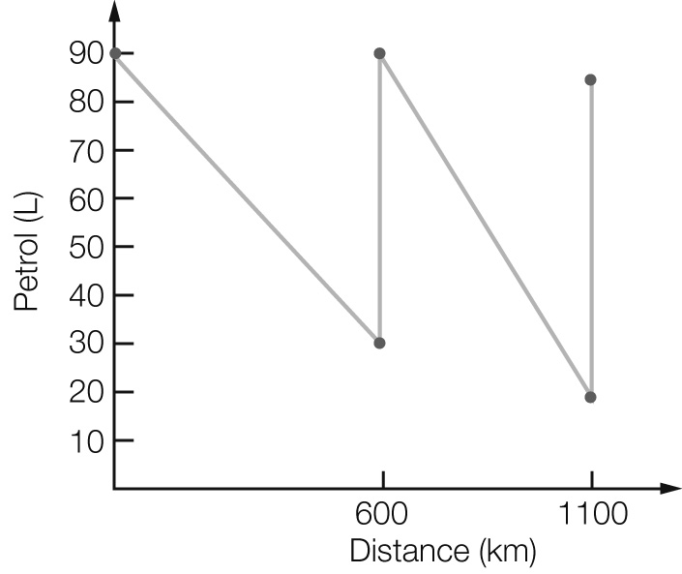

(c) The car used 60 L over 600 km (10 L/100 km) for the first part of the trip, and 70 L over 500 km (14 L/100 km) for the second part of the trip.

(d) The line falls more steeply for the second part.

Question 26 5 marks [6.3]

(a)

|  |  |
| --- | --- |
| Number of squares  (*s*) | Number of matches  (*m*) |
| 1 | 4 |
| 2 | 7 |
| 3 | 10 |
| 4 | 13 |
| 5 | 16 |

(b) 

(c)

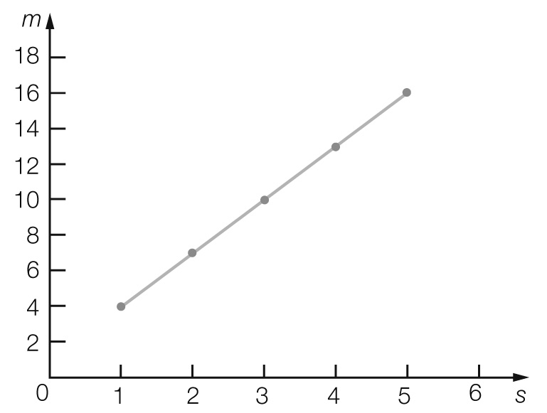

(d) For *s* = 10, *m* = 3 × 10 + 1

= 31 matches

Question 27 4 marks [6.3]

(a) *C* = 30 + 20*t*

(b)

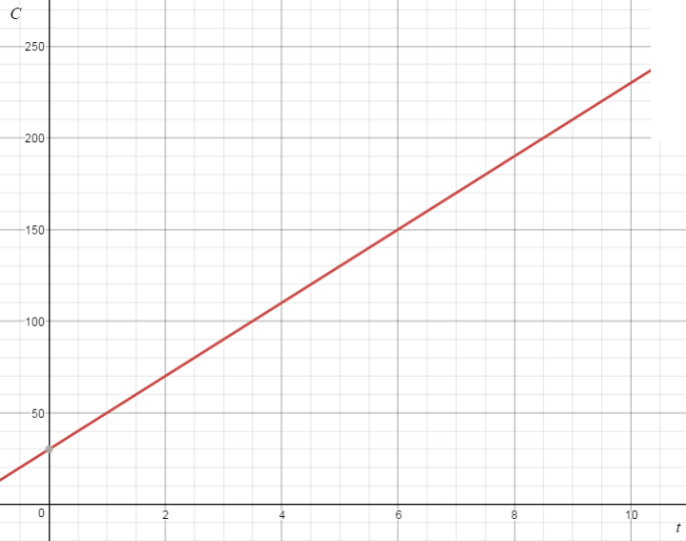

(c) *C* = 30 + 20*t*

= 30 + 20 × 3.25

= $95

Question 28 4 marks [6.4]

(a) $2.05

(b) 

(c) *T* = 1.8 + 0.25 × 20

= $6.80

Question 29 5 marks [6.4]

(a)

|  |  |  |  |  |  |  |  |
| --- | --- | --- | --- | --- | --- | --- | --- |
| Number of inches | 0 | 1 | 2 | 3 | 4 | 5 | 10 |
| Number of mm | 0 | 25 | 50 | 75 | 100 | 125 | 250 |

(b) *m* = 25*n*

(c)

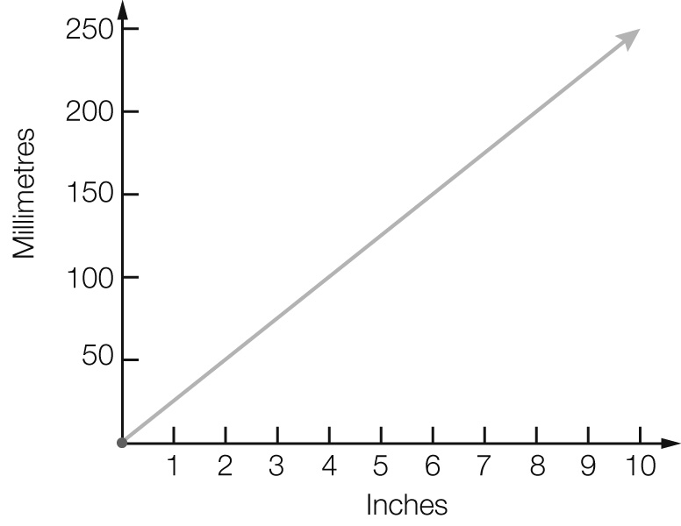

(d) *m* = 25*n*

*m* = 25 × 1.5

= 37.5

(e) *m* = 25*n*

1000 = 25 × *n*



*n* = 40

Extended answer total marks: 23

TOTAL test marks: 71